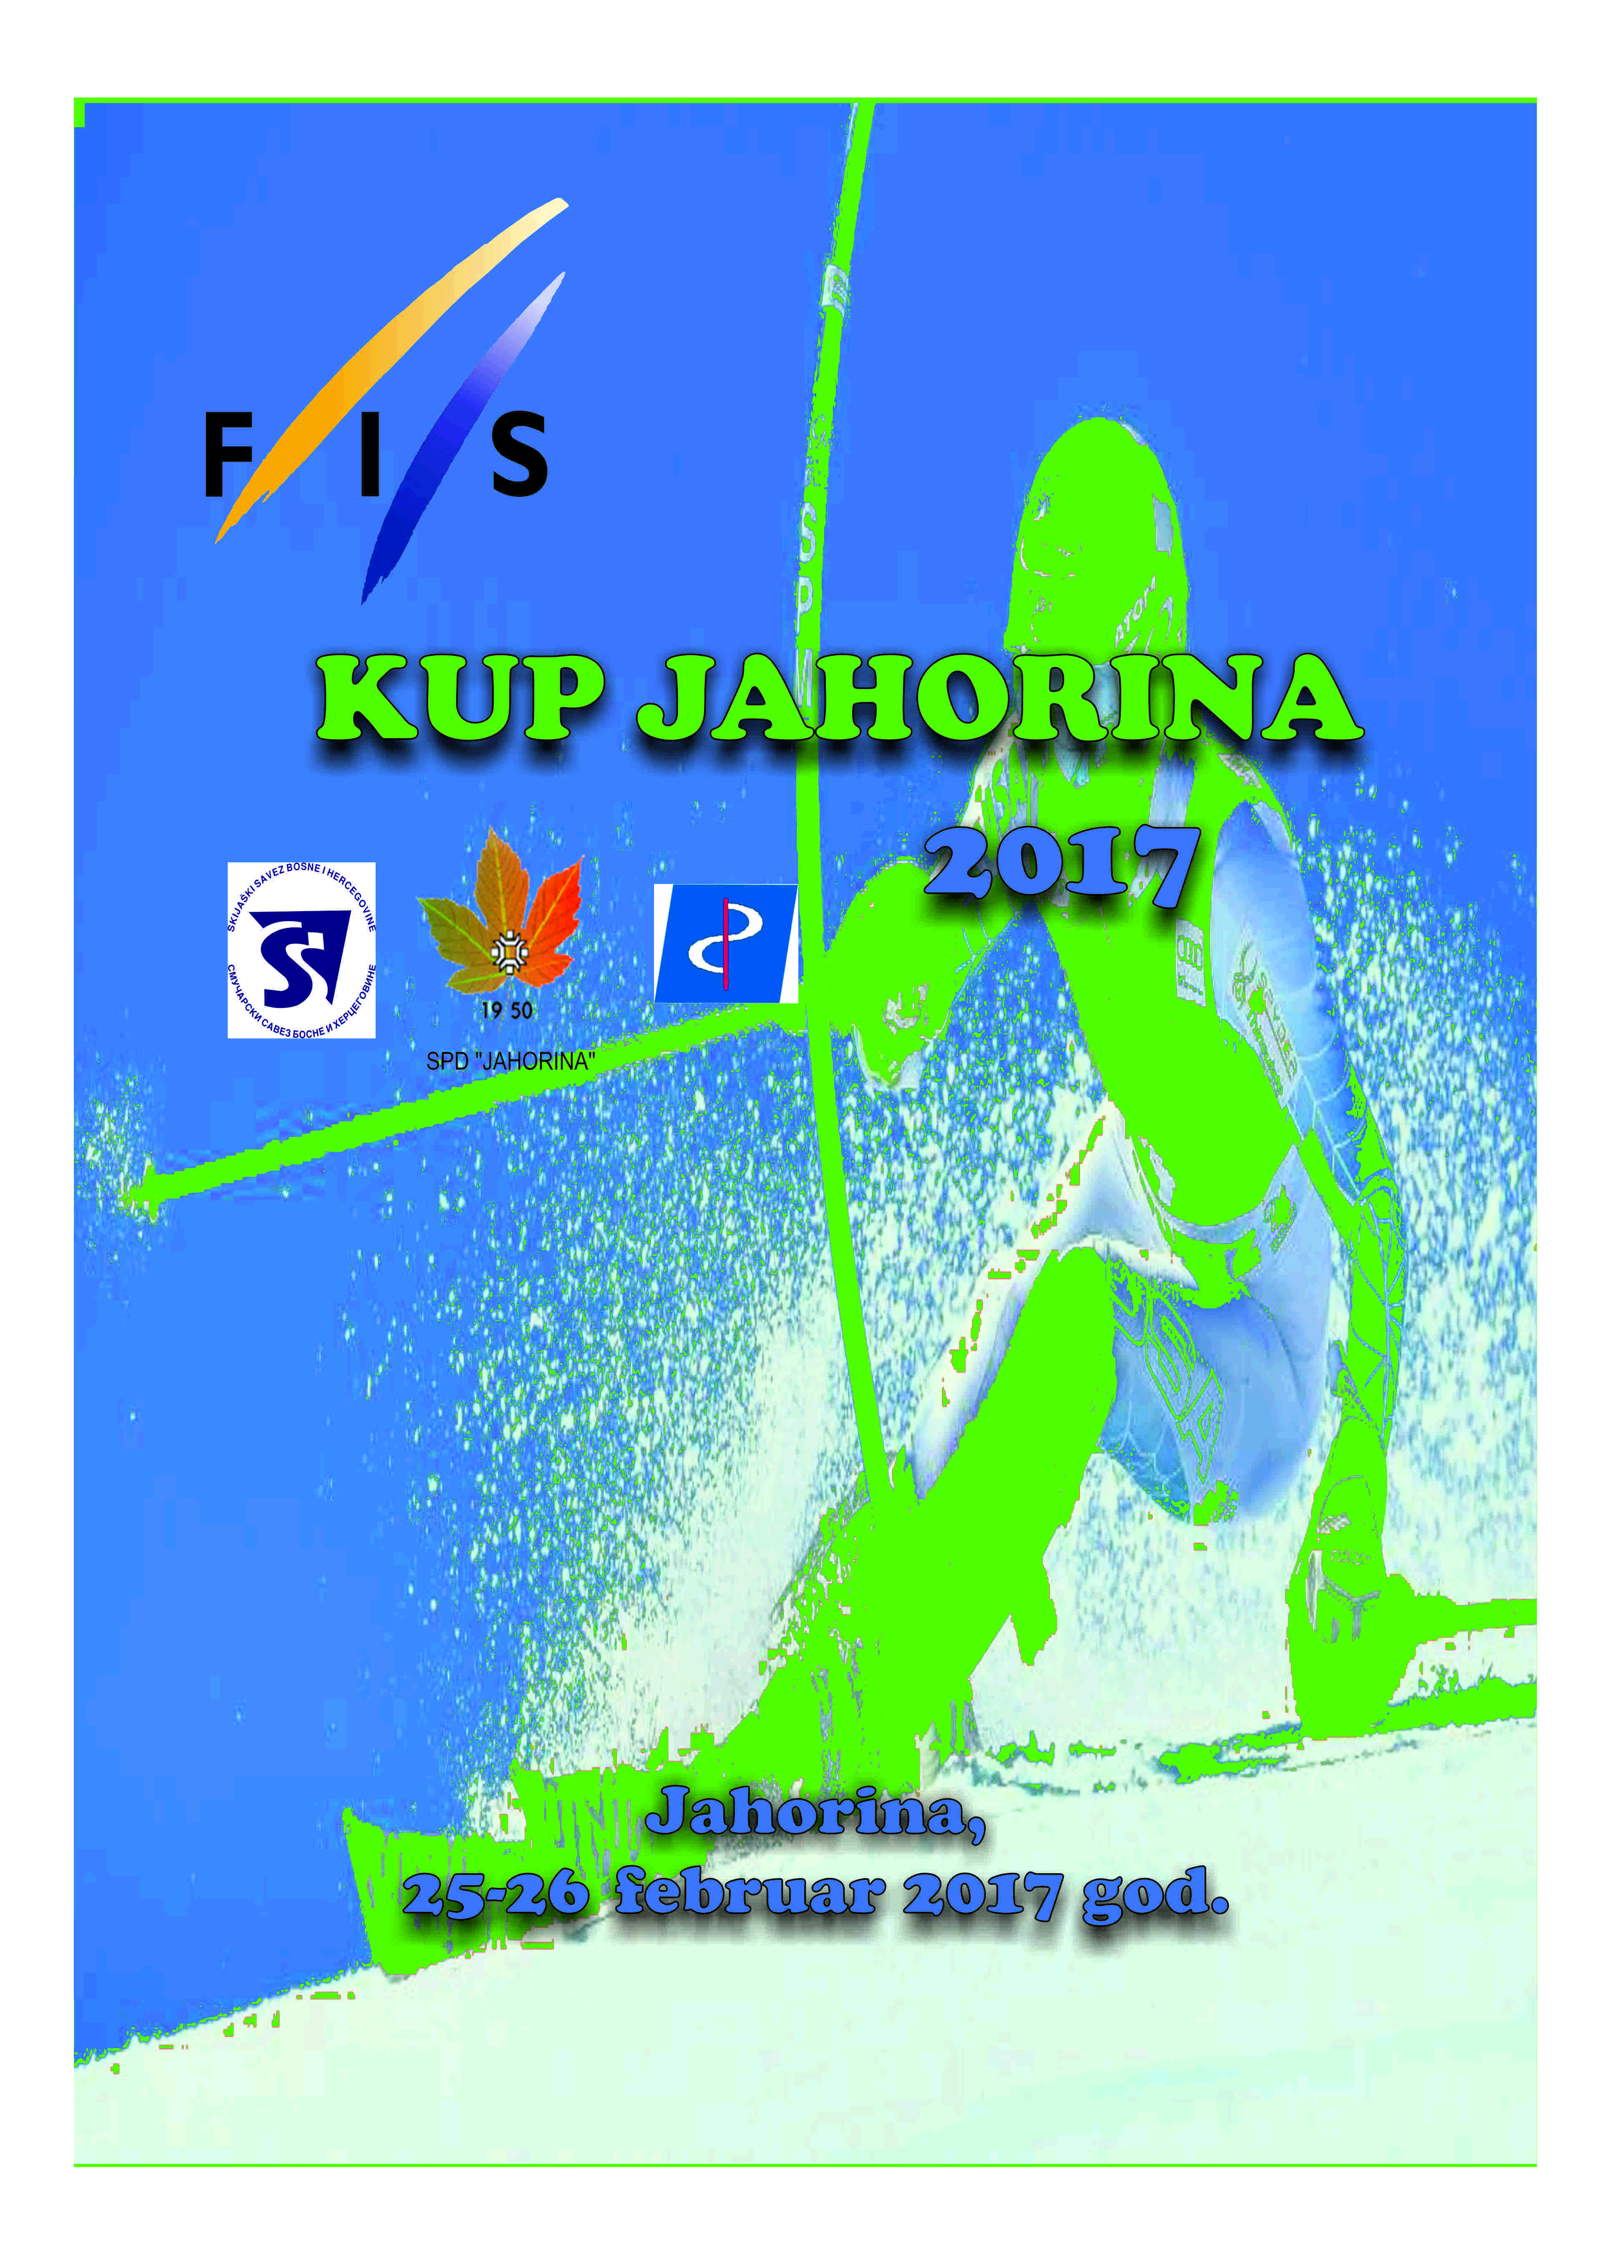

XV FIS CUP JAHORINA 2017

LADIES & MEN
GIANT SLALOM & SLALOM

JAHORINA
24.02 – 26.02.2017.god
P R O G R A M

Fri, 24.02.2017. Arrival of the teams
19.00 – Team captains' meeting
- Team captains’ meeting will be held in Hotel Bistrica – Jahorina

Sat, 25.02.2017.
09.00 – GIANT SLALOM – Ladies & Men – 1 run
12.30 – GIANT SLALOM – Ladies & Men – 2 run
- Prize giving ceremony; 14.30 hours, Giant Slalom Finish Area, Jahorina

16.00 - Team captains' meeting
- Team captains’ meeting will be held in Hotel Bistrica – Jahorina

Sun, 26.02.2017.
09.30 – SLALOM – Ladies & Men – 1 run
12.00 – SLALOM – Ladies & Men – 2 run
- Prize giving ceremony; 14.00 hours, Slalom Finish Area, Jahorina

PRIZES
- 1st – 3rd place FIS CUP JAHORINA CHAMPS receive medals and practical prizes
- Total prize money 1400 eura

GENERAL REGULATIONS:
- FIS CUP JAHORINA will be held upon FIS Regulations and ICR Rules
- Organizing Committee has all rights to change the program
- Athletes and coaches are responsible for their insurance by themselves
- National ski federations are responsible for entries of their competitors
- Only athletes with valid FIS code may be entered
- Number of athletes per nation is according to the FIS rules


OFFICIAL INVITATION TO THE FIS CUP JAHORINA IN ALPINE DISCIPLINES 2017.

ORGANIZING COMMITTEE:
Organizer: Ski Federation of Bosnia and Herzegovina
Technical organizer: SPD Jahorina
Chairman of Organizing Committee: Dr Jasmina Davidović
Secretary: Vesna Šljuka (+38765490869)
Secretary Assistant:

RACE COMMITTEE:
Technical Delegate FIS:
Chief of race: Vladimir Lučić (+38765524808)
Chief of course: Mladen Nešković
Timing: SPD Jahorina
Chief of gatekeepers: Slaviša Lučić

INFORMATION AND ENTRY FORMS

SMUČARSKO-PLANINARSKO DRUŠTVO JAHORINA

Serdar Janka Vukotića bb
71420 Pale
Republika Srpska, Bosna i Hercegovina
Tel/Fax: +38757223208
e-mail: spdjahorina@zona.ba

Entries should be sent on the official FIS Entry form until 12.00 hours on 24.02.2017. to the abovementioned contact or through the office of Bosnia and Herzegovina Ski Federation

ACCOMODATION:

Hotel Bistrica, Jahorina

Tel: +38757270020

All other information on:

Smučarsko-planinarsko društvo Jahorina – Ski klub “Jahorina”

Tel/Fax: +38757223208, Mob: +38765490869

Athletes under 25 FIS points and their coaches have accommodation free of charge. All others are responsible for accommodation costs by themselves or their ski federations.

RACE OFFICE:

Hotel Bistrica, Jahorina

Tel: +38757270020
- Race office is open from 24.02.2015. at 16.00 hours

FIRST AID SERVICE:

Dom zdravlja Pale, Olimpijski centar Pale

TECHNICAL INFORMATION OF THE RACE COURSES

GIANT SLALOM:
Name of the Course: Olimpijski veleslalom (Prača)
Start: 1840 m
Finish: 1660 m
Vertical drop: 180 m
FIS homologation No 10954/06/13

SLALOM:
Name of the Course: Olimpijski veslalom (Prača)
Start: 1840 m
Finish: 1660 m
Vertical drop: 180 m
FIS homologation No 10954/06/13

